The typing performance and preference costs of reducing tactile feedback and tactile landmarks in tablet keyboards

Button Tactile boundary Tactile feedback Pressure detection

【Main content】：

Study the effects of haptic feedback, haptic boundaries, and whether the hand can be placed on the keyboard.

【Four keyboards involved in this study】：

**On screen keyboard (OSK):** There is neither a tactile boundary nor tactile or audio feedback when the key is triggered. Trigger a key when your finger leaves the screen.

**Capacitive keyboard:** The keyboard does not provide tactile or audio feedback for the keys. However, it provides limited tactile boundary through the key top shape.

**Microsoft Surface Touch Cover:** The touch screen uses force sensors to sense keys. The keyboard does not provide tactile or audio feedback for the keys.

**Microsoft Surface Type Cover:** Has a removable physical button that provides haptic and some audio feedback when pressed.

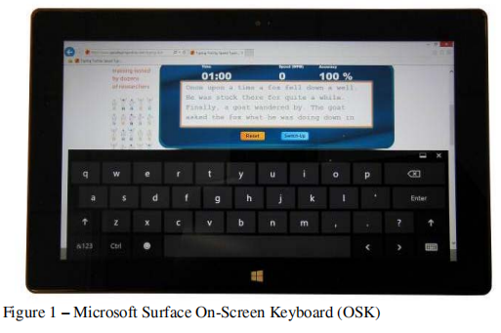 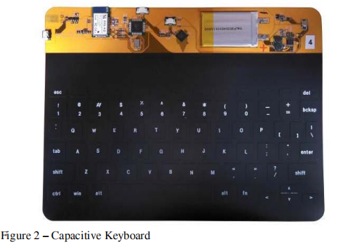

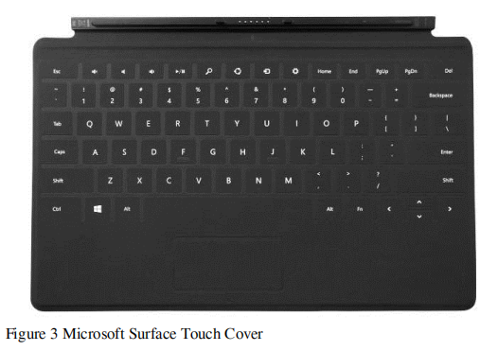 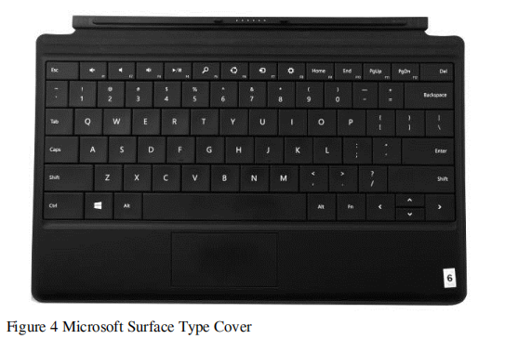

【Experiments】：

Procedure：

Step1: Participants are required to feel the feeling of the keyboard after trying the keyboard for about 30 seconds, and rank the feeling of the keyboard from best to worst.

Step2: After the ranking is completed, a series of typing tests will be run on each keyboard.

Step3: On the typing task, they need to perform a one-minute warm-up period in order to type on each keyboard, then take a break, and then perform a two-minute typing task to collect typing performance data.

Step4: After the typing task is over, ask the participants about their typing experience.

Indicates：

The software automatically calculated net typing speed (the gross typing speed minus the number of missed words, expressed in words-per-minute (WPM)) and accuracy (the percentage of words typed correctly).

Accuracy

Results:

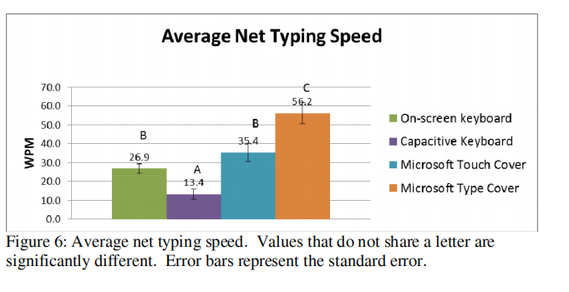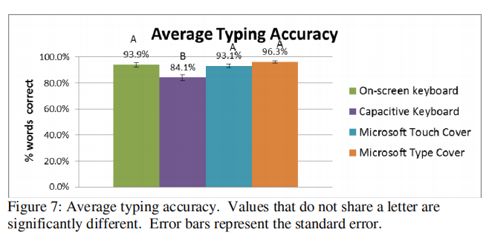

Discuss:

The typing speed of traditional keyboards with haptic feedback (Type Cover) is much higher. Keyboards with haptic signs but no haptic feedback show different effects on typing speed compared to OSK, depending on whether the user can Drop your finger.

(Detail in parper)

【Subjective analysis】：

**Disadvantages:**

1. Only consider the key border and click feedback, but do not consider the effect of keyboard material on typing, so 1 and 2 cannot be directly compared
2. Only studying the interaction between traditional keyboards and virtual keyboards, and did not introduce tactile feedback into the research

**Next:**

1. DO this experiment on a screen with haptic feedback. Independent variables: haptic boundary, vibration feedback, button click simulation feedback